Database Management Systems Lab Work

1.Create a table Staff with attributes Staff_no, Firstname, Lastname, position, DOB, Salary, Branch_no with Staff_no as primary key.

2.Insert six rows in it.

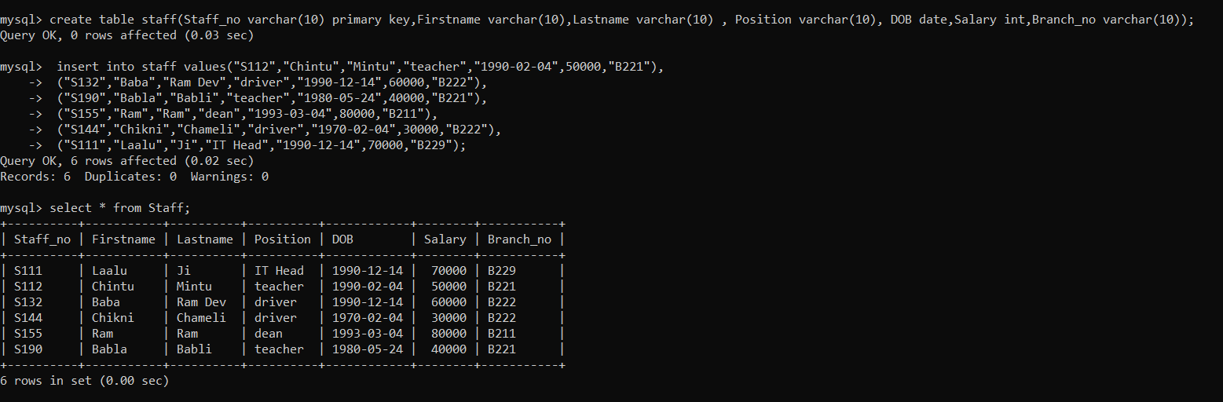

3.Create a view so that manager at branch B222 can see only the details for staff who work in his/her branch office.

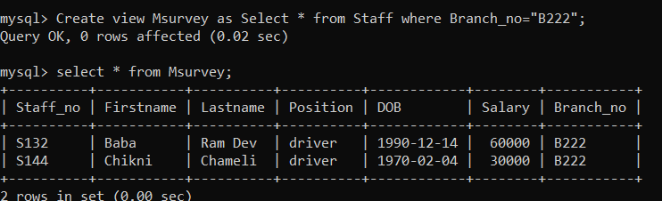

4.Create a view staffdetails200 that excludes salary info so that only managers can access the salary details for the staff who work at their branch.

